LAB ACTIVITY (Lab-06)

1. Bank Account System
- Create a base class Account with attributes: accountNumber, balance.
- Add a constructor to initialize values.
- Create subclasses SavingsAccount and CurrentAccount that inherit Account.
- Implement method overloading for deposit() (e.g., deposit with int or double).
- Implement method overriding for withdraw() in subclasses with different rules (e.g., savings has
minimum balance, current has overdraft).

class Account {
String accNo;
double balance;

// Constructor
Account(String accNo, double balance) {
this.accNo = accNo;
this.balance = balance;
}

// Deposit with no amount (just showing account details)
void deposit() {
System.out.println("Deposit operation:");
System.out.println("Account No: " + accNo + ", Balance: " + balance);
}

// Overloaded deposit methods
void deposit(int amount) {
balance += amount;
System.out.println("Deposited: " + amount +
" | Account No: " + accNo +
" | Balance: " + balance);
}

void deposit(double amount) {
balance += amount;
System.out.println("Deposited: " + amount +
" | Account No: " + accNo +
" | Balance: " + balance);
}

// Withdraw (base version)
void withdraw(double amount) {
System.out.println("Withdraw request: " + amount);
}
}

// Savings Account
class SavingsAccount extends Account {
public static final double MIN_BALANCE = 5000.00;

SavingsAccount(String accNo, double balance) {
super(accNo, balance);
}

@Override
void withdraw(double amount) {
if (balance - amount >= MIN_BALANCE) {
balance -= amount;
System.out.println("Withdrawal of " + amount + " successful. Updated Balance: " + balance);
} else {
System.out.println("Withdrawal denied! Minimum balance of " + MIN_BALANCE + " must be maintained.");
}
}
}

// Current Account
class CurrentAccount extends Account {
public static final double LOCK_AMOUNT = 1000.00;

CurrentAccount(String accNo, double balance) {
super(accNo, balance);
}

@Override
void withdraw(double amount) {
if (balance - amount >= LOCK_AMOUNT) {
balance -= amount;
System.out.println("Withdrawal of " + amount + " successful. Updated Balance: " + balance);
} else {
System.out.println("Withdrawal denied! Lock amount of " + LOCK_AMOUNT + " must remain in account.");
}
}
}

// Main Class
public class MainBank {
public static void main(String[] args) {

// Base Account
Account a1 = new Account("40004007", 2000.50);
a1.deposit();
a1.deposit(1000);
a1.deposit(275.50);
a1.withdraw(10000);

System.out.println("--------------------------");

// Savings Account
SavingsAccount s1 = new SavingsAccount("40004008", 7000.00);
s1.deposit();
s1.deposit(10000);
s1.deposit(2755.50);
s1.withdraw(1200);
s1.withdraw(6000);

System.out.println("--------------------------");

// Current Account
CurrentAccount c1 = new CurrentAccount("40004009", 5000.00);
c1.deposit();
c1.deposit(1000);
c1.deposit(275.50);
c1.withdraw(1500);
c1.withdraw(4500);
}
}

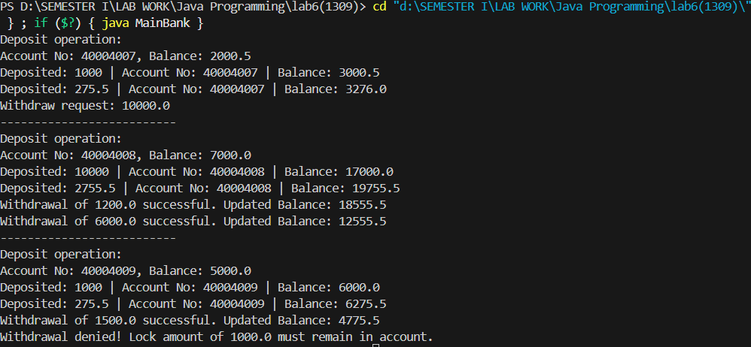

2. Vehicle Hierarchy
- Create a base class Vehicle with attributes speed and fuel.
- Add a constructor.
- Create subclasses: Car, Bike, Truck.
- Use method overloading for accelerate() (accelerate with or without specifying gear).
- Use method overriding to provide different mileage calculation logic in each subclass.

// Base Class
class Vehicle {
protected int speed; // in km/h
protected double fuel; // in liters

// Constructor
public Vehicle(int speed, double fuel) {
this.speed = speed;
this.fuel = fuel;
}

// Method overloading: accelerate
public void accelerate() {
speed += 10;
System.out.println("Vehicle accelerated by 10 km/h. Current speed: " + speed);
}

public void accelerate(int gear) {
speed += gear * 10;
System.out.println("Vehicle accelerated with gear " + gear + ". Current speed: " + speed);
}

// Method to be overridden
public double mileage() {
System.out.println("Generic vehicle mileage calculation.");
return 0.0;
}

public void display() {
System.out.println("Speed: " + speed + " km/h, Fuel: " + fuel + " liters");
}
}

// Car subclass
class Car extends Vehicle {
public Car(int speed, double fuel) {
super(speed, fuel);
}

@Override
public double mileage() {
double mileage = fuel * 15; // assume 15 km/l
System.out.println("Car mileage: " + mileage + " km");
return mileage;
}
}

// Bike subclass
class Bike extends Vehicle {
public Bike(int speed, double fuel) {
super(speed, fuel);
}

@Override
public double mileage() {
double mileage = fuel * 40; // assume 40 km/l
System.out.println("Bike mileage: " + mileage + " km");
return mileage;
}
}

// Truck subclass
class Truck extends Vehicle {
public Truck(int speed, double fuel) {
super(speed, fuel);
}

@Override
public double mileage() {
double mileage = fuel * 8; // assume 8 km/l
System.out.println("Truck mileage: " + mileage + " km");
return mileage;
}
}

// Main class
public class MainVehicle {
public static void main(String[] args) {
// Car
Car car = new Car(60, 20);
car.display();
car.accelerate();
car.accelerate(2);
car.mileage();

System.out.println("--------------------------");

// Bike
Bike bike = new Bike(40, 5);
bike.display();
bike.accelerate();
bike.accelerate(3);
bike.mileage();

System.out.println("--------------------------");

// Truck
Truck truck = new Truck(50, 50);
truck.display();
truck.accelerate();
truck.accelerate(4);
truck.mileage();
}
}

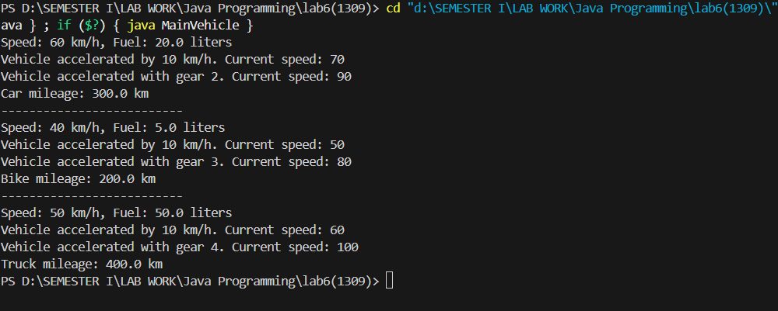

3. Shape Area Calculator
- Create a base class Shape.
- Create subclasses: Circle, Rectangle, Triangle.
- Add constructors for each subclass.
- Implement method overloading in Rectangle (area with length & breadth OR with side only for square).
- Implement method overriding of calculateArea() for each shape.

// Base Class
abstract class Shape {
// Abstract method to be overridden
public abstract double calculateArea();
}

// Circle subclass
class Circle extends Shape {
private double radius;

public Circle(double radius) {
this.radius = radius;
}

@Override
public double calculateArea() {
double area = Math.PI * radius * radius;
System.out.println("Circle area: " + area);
return area;
}
}

// Rectangle subclass
class Rectangle extends Shape {
private double length;
private double breadth;

// Constructor for rectangle
public Rectangle(double length, double breadth) {
this.length = length;
this.breadth = breadth;
}

// Constructor for square
public Rectangle(double side) {
this.length = side;
this.breadth = side;
}

// Method overloading for area
public double area(double length, double breadth) {
return length * breadth;
}

public double area(double side) {
return side * side;
}

@Override
public double calculateArea() {
double area = length * breadth;
System.out.println("Rectangle area: " + area);
return area;
}
}

// Triangle subclass
class Triangle extends Shape {
private double base;
private double height;

public Triangle(double base, double height) {
this.base = base;
this.height = height;
}

@Override
public double calculateArea() {
double area = 0.5 * base * height;
System.out.println("Triangle area: " + area);
return area;
}
}

// Main class
public class MainShapeArea {
public static void main(String[] args) {
// Circle
Circle circle = new Circle(7);
circle.calculateArea();

System.out.println("--------------------------");

// Rectangle
Rectangle rect = new Rectangle(10, 5);
rect.calculateArea();
System.out.println("Overloaded method (Rectangle 8x4): " + rect.area(8, 4));
System.out.println("Overloaded method (Square 6): " + rect.area(6));

System.out.println("--------------------------");

// Triangle
Triangle tri = new Triangle(10, 6);
tri.calculateArea();
}
}

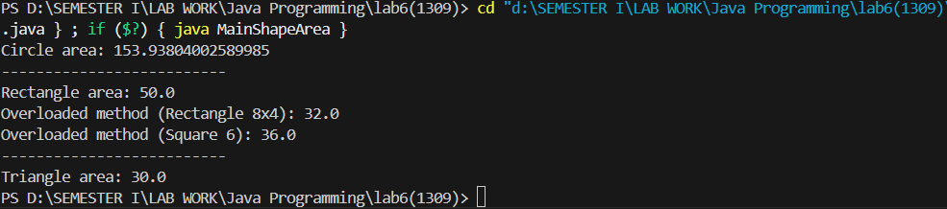

4. Employee Payroll System
- Create a base class Employee with attributes: name, salary.
- Add constructors (default + parameterized).
- Create subclasses: Manager, Developer, Intern.
- Implement method overloading for calculateBonus() (bonus with percentage OR fixed amount).
- Implement method overriding in subclasses to calculate bonus differently based on role.

// Base class
class Employee {
protected String name;
protected double salary;

// Default constructor
public Employee() {
this.name = "Unknown";
this.salary = 0.0;
}

// Parameterized constructor
public Employee(String name, double salary) {
this.name = name;
this.salary = salary;
}

// Method overloading: calculateBonus
public double calculateBonus(double percentage) {
double bonus = (salary * percentage) / 100;
System.out.println(name + " bonus (" + percentage + "%): " + bonus);
return bonus;
}

public double calculateBonus(int fixedAmount) {
System.out.println(name + " fixed bonus: " + fixedAmount);
return fixedAmount;
}

// Method to override in subclasses
public double calculateBonus() {
System.out.println("Generic employee bonus calculation.");
return 0.0;
}

public void display() {
System.out.println("Employee: " + name + ", Salary: " + salary);
}
}

// Manager subclass
class Manager extends Employee {
public Manager(String name, double salary) {
super(name, salary);
}

@Override
public double calculateBonus() {
double bonus = salary * 0.20; // Managers get 20% bonus
System.out.println("Manager " + name + " bonus: " + bonus);
return bonus;
}
}

// Developer subclass
class Developer extends Employee {
public Developer(String name, double salary) {
super(name, salary);
}

@Override
public double calculateBonus() {
double bonus = salary * 0.15; // Developers get 15% bonus
System.out.println("Developer " + name + " bonus: " + bonus);
return bonus;
}
}

// Intern subclass
class Intern extends Employee {
public Intern(String name, double salary) {
super(name, salary);
}

@Override
public double calculateBonus() {
double bonus = 1000; // Interns get a fixed stipend bonus
System.out.println("Intern " + name + " bonus: " + bonus);
return bonus;
}
}

// Main class
public class MainEmployee {
public static void main(String[] args) {
// Manager
Manager m1 = new Manager("Alice", 80000);
m1.display();
m1.calculateBonus();
m1.calculateBonus(10.0); // Overloaded
m1.calculateBonus(5000); // Overloaded

System.out.println("--------------------------");

// Developer
Developer d1 = new Developer("Bob", 60000);
d1.display();
d1.calculateBonus();
d1.calculateBonus(12.5);
d1.calculateBonus(3000);

System.out.println("--------------------------");

// Intern
Intern i1 = new Intern("Charlie", 20000);
i1.display();
i1.calculateBonus();
i1.calculateBonus(5.0);
i1.calculateBonus(1000);
}
}

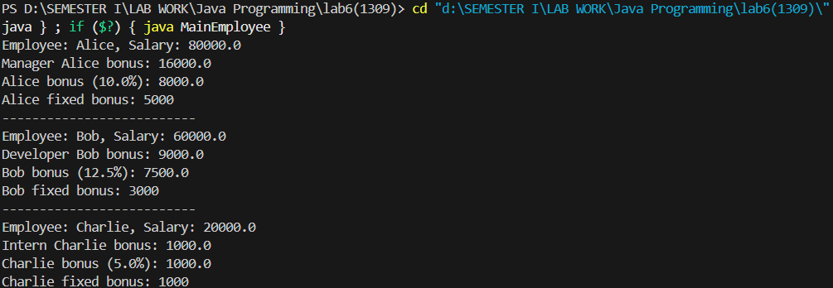

5. Library Management System
- Create a base class Book with attributes: title, author, price.
- Add constructors.
- Create subclasses: EBook and PrintedBook.
- Use method overloading for applyDiscount() (apply discount by percentage or fixed amount).
- Use method overriding to calculate getFinalPrice() differently for EBook (download fee) and PrintedBook (printing/shipping cost).

// Base class
class Book {
protected String title;
protected String author;
protected double price;

// Default constructor
public Book() {
this.title = "Unknown";
this.author = "Unknown";
this.price = 0.0;
}

// Parameterized constructor
public Book(String title, String author, double price) {
this.title = title;
this.author = author;
this.price = price;
}

// Method overloading: applyDiscount
public void applyDiscount(double percentage) {
double discount = (price * percentage) / 100;
price -= discount;
System.out.println("Applied " + percentage + "% discount. New price: " + price);
}

public void applyDiscount(int amount) {
price -= amount;
if (price < 0) price = 0; // Prevent negative price
System.out.println("Applied fixed discount of " + amount + ". New price: " + price);
}

// Method to override
public double getFinalPrice() {
System.out.println("Generic book final price calculation.");
return price;
}

public void display() {
System.out.println("Title: " + title + " | Author: " + author + " | Price: " + price);
}
}

// EBook subclass
class EBook extends Book {
private double downloadFee = 50.0; // Extra cost for download

public EBook(String title, String author, double price) {
super(title, author, price);
}

@Override
public double getFinalPrice() {
double finalPrice = price + downloadFee;
System.out.println("EBook Final Price (including download fee): " + finalPrice);
return finalPrice;
}
}

// PrintedBook subclass
class PrintedBook extends Book {
private double shippingCost = 100.0; // Extra cost for shipping/printing

public PrintedBook(String title, String author, double price) {
super(title, author, price);
}

@Override
public double getFinalPrice() {
double finalPrice = price + shippingCost;
System.out.println("Printed Book Final Price (including shipping): " + finalPrice);
return finalPrice;
}
}

// Main class
public class MainLibrary {
public static void main(String[] args) {
// EBook
EBook ebook = new EBook("Digital Java", "Alice", 500);
ebook.display();
ebook.applyDiscount(10); // 10% discount
ebook.applyDiscount(50); // Fixed discount
ebook.getFinalPrice();

System.out.println("--------------------------");

// PrintedBook
PrintedBook pbook = new PrintedBook("Learn OOP", "Bob", 800);
pbook.display();
pbook.applyDiscount(20); // 2
}
}

